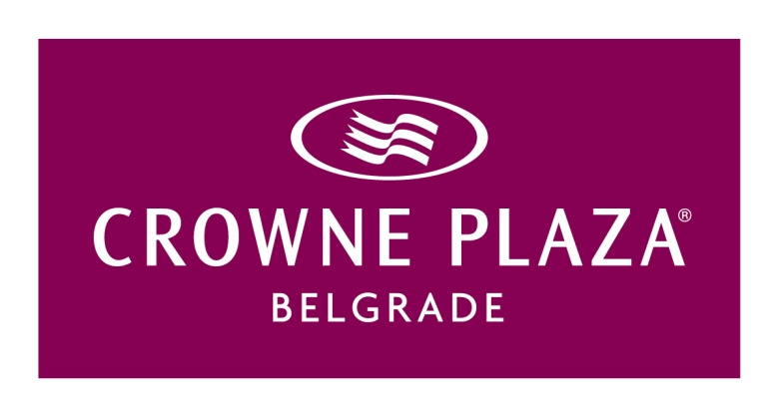

Hotel Reservation Form, Advantix

Kindly return this form to our reservation department.
Fax: +381112223114 / Email: begcp.reservations@ihg.com

Keyword:T56

Name: _______________________________First Name:_________________________________

Company: _______________________________________________________________________

Telephone number: ______________________Fax number: ________________________________

Email address: ____________________________________________________________________

Check-In (Date): ______________________Check-Out (Date): _____________________________

Arrival Time: ______________________________________________________________________
(Please note that check-in can only be guaranteed after 03:00 pm)

Requested Room Type:

Superior Room (single occupancy): € 100,00 / Night incl. breakfast (incl. VAT)

Superior Room (double occupancy): € 110, 00 / Night incl. breakfast (incl. VAT)

We are pleased to note down the following special requests in your reservation. However please note that room allocation will be done upon availability and that the following requests cannot be guaranteed:

Queen Bed King Bed twin beds

In case on non-arrival (no show) or cancellation thereafter (late cancellation), cancellation fees of 100% of the above mentioned room rate will be charged per night for the duration of stay scheduled. The general terms and conditions of the hotel apply.

Reservation can be cancelled or modified without penalty until June 01, 2017.

Please fill in your credit card details to confirm your booking (In case of no show or late cancellation this credit card will be charged with the respective cancellation fees):

Credit Card Type: ________________________________________________________________

Card Holder: _______________________________________valid til:____________________

Card Number: ___________________________________________________________________

Signature: _____________________________________________

